Reset box
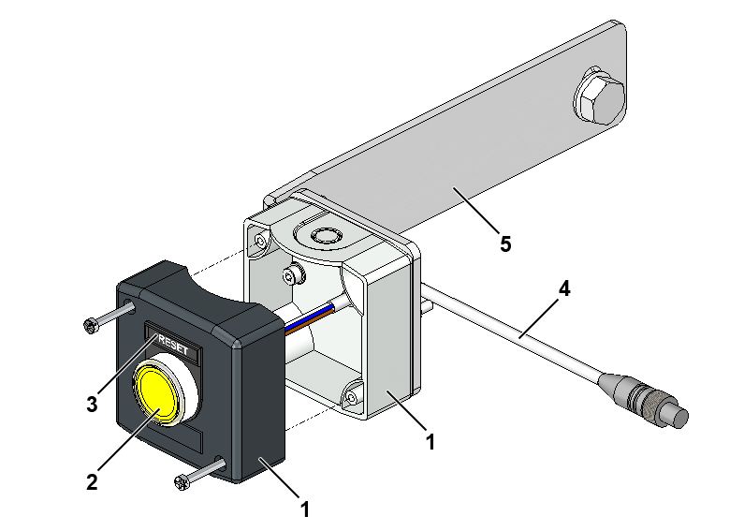
Fig. 1-1 Reset box
1. | Control box | 4. | Signal cable, 4-pole
2. | Illuminated pushbutton | 5. | Bracket for fastening to frame
3. | “RESET” label

Preparation necessary
The relevant safety function must be installed before the reset box is fitted:
LS-4000E: NAT-SPS, NAT and/or IOC
LS-4000CB: IOB

Tools
Part No. | Description | Qty
161A239 | Torque wrench 8-60 Nm | 1
161A240 | Reversible ratchet insert tool ½" | 1
161A241 | Socket ½” 17 mm | 1
161A251 | Combination wrench, 17 mm | 1

Guides
- Electrical component location drawing
- Wiring diagram for IOC, NAT or IOB
- I/O lists

Installation guide
The reset box has to be positioned after the relevant safety function (IOC, NAT or IOB) at a distance equivalent to the sorter’s braking distance.
.1 Stop the sorter using the relevant safety function: IOC, NAT or IOB.
.2 Put the reset box on the fame nearest to where the sorter stopped.
.3 Mount the reset box on the frame using the two M10 screws as shown in Fig. 1-2.
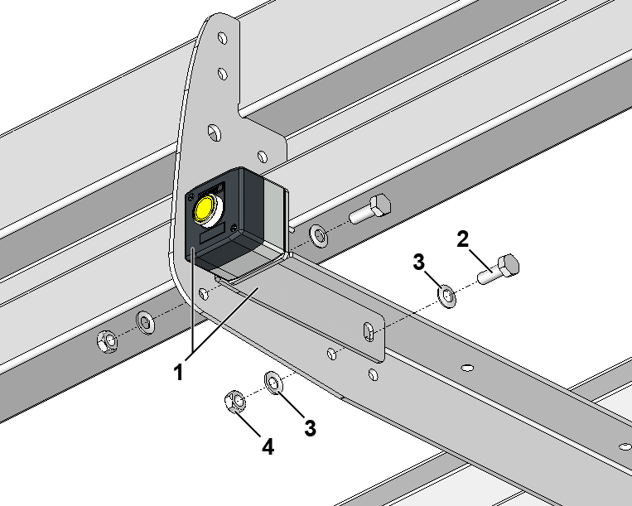
Fig. 1-2 Mounting reset box, complete
1. | Reset box, with bracket, complete
2. | Screw, M10x30
3. | Contact washer, Ø10/Ø20 mm
4. | Nut, M10

.4 Secure the reset box as shown in Fig. 1-3.
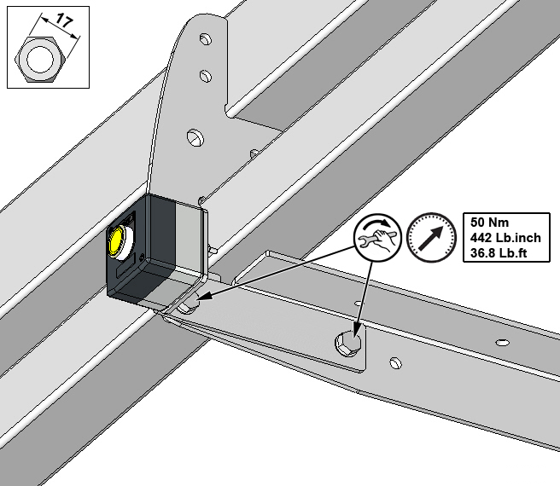
Fig. 1-3 Securing reset box
.5 Feed the reset box’s signal cable into the sorter frame’s left-hand cable tray – as seen in the direction of travel. If necessary, use a cable exit for the cable.
.6 Connect the reset box’s signal cable to one of the following cables, depending on the overall safety function:
Safety function | Item No. | Designation
NAT-SPS | 469B007.0100 | Connection cable for I/O modules, M8, 4-pole
NAT, IOC, IOB | 174A954 | Connection cable for I/O modules, Y-split, M8, 3-pole

.7 Connect the cable in an I/O module in accordance with the I/O list.

